

AGENDA PAPERS FOR

ACCOUNTS AND AUDIT COMMITTEE

Date: Wednesday, 21st November 2012

Time: 6.30 p.m.

Place: Room 10, Ground Floor, Quay West, Trafford Wharf Road,
Trafford Park, Manchester M17 1HH

 | A G E N D A PART I | Enclosure  No. | Proper Officer  under L.G.A., 1972, S.100D (background papers):
1. | ATTENDANCES  To note attendances, including Officers and any apologies for absence.
2. | MINUTES  To receive and if so determined, to approve as a correct record the Minutes of the meeting held on 26th September 2012. | 2 | 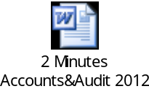
3. | AUDIT AND ASSURANCE REPORT FOR THE PERIOD JULY TO SEPTEMBER 2012  To note a report of the Audit and Assurance Manager. | 3 | 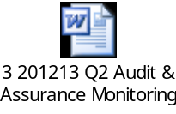
4. | ANNUAL AUDIT LETTER 2011/12  To consider the External Auditor’s Annual Audit Letter summarising the 2011/12 audit of the Council. | 4 | 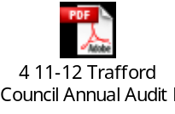

5. | ANTI-FRAUD AND CORRUPTION STRATEGY, POLICY AND SUPPORTING GUIDANCE  To consider a report of the Audit and Assurance Manager. | 5 | 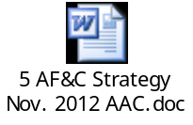
6. | TREASURY MANAGEMENT 2012/13 MID-YEAR PERFORMANCE REPORT  To consider a joint report of the Executive Member for Finance and the Acting Corporate Director Transformation and Resources. | 6 | 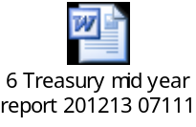
7. | RESERVES AND PROVISIONS  To consider a report of the Acting Corporate Director Transformation and Resources. | 7 | 
8. | PRESENTATION ON THE COUNCIL’S INSURANCE ARRANGEMENTS  To receive a presentation from the Acting Corporate Director Transformation and Resources.
9. | INSURANCE PERFORMANCE REPORT  To consider a report of the Acting Corporate Director Transformation and Resources. | To Follow
10. | ACCOUNTS AND AUDIT COMMITTEE – WORK PROGRAMME – 2012/13  To note a report of the Audit and Assurance Manager. | 10 | 
11. | URGENT BUSINESS (IF ANY)  Any other item or items which by reason of special circumstances (to be specified) the Chairman of the meeting is of the opinion should be considered at this meeting as a matter of urgency.
THERESA GRANT
Chief Executive.

Contact Officer: Ian Cockill
Extn. 1387.

